Dissertation

1. List the key findings – one sentence each, order from most exciting to least, or another logical order
2. Make figures for each key finding – place in pre-determined order
3. Write results around each finding – place in pre-determined order
4. Write methods around each result – only include methods needed to describe the science leading to the results presented
5. Write first paragraph of discussion – summarise all the key findings in order
6. Write the last paragraph of the intro – describes the research questions, hypotheses and/or objectives of the study – the study roadmap
7. Write the next paragraphs of the discussion – one paragraph per each key finding in order, discussions often also include a study limitations paragraph and a future research directions paragraph
8. Write the introduction paragraphs – one paragraph per topic of each of the key findings, should match with the content in the discussion paragraphs
9. Write the first paragraph of the introduction – provides the big picture context and sets out the clear knowledge gap of the study.
10. Write the conclusion paragraph – the last paragraph of the discussion or it’s own section, should explain why the research matters and put the key findings back into the big picture context set out in the first paragraph of the intro
11. Write the abstract – should include your entire pitch and should ideally follow the Nature abstract structure

Results

Key findings:

H1

**How do Arctic Vegetation types be discriminate based on the mean and variance of hyperspectral signatures?**



Reflectance and spectral diversity

The sampling date of field spectral data resulted in clear differences in both the observed reflectance and spectral diversity observed between the two vegetation types. (This has significant implications on subsequent analysis) (Wang et al., 2018).

The tends in reflectance across all vegetation types and years corresponded with typical reflectance patterns across the electromagnetic spectrum. High levels of absorption where seen in the green and blue spectral regions that correspond with the chlorophyll, caratanoid and other pigment absorption. A relative with a “vally” before the red edge transition and high reflectance in the (late) NIR and IR regions caused by multiple scattering (woody material/compositional features)(maybe attempts to link to one vegetation type) (Wang et al., 2018).

Vegetation types can be discriminated based on their spectral signatures, but exhibit variable and complex



**Does band selection influence correspondence between spectral diversity and vegetation types**

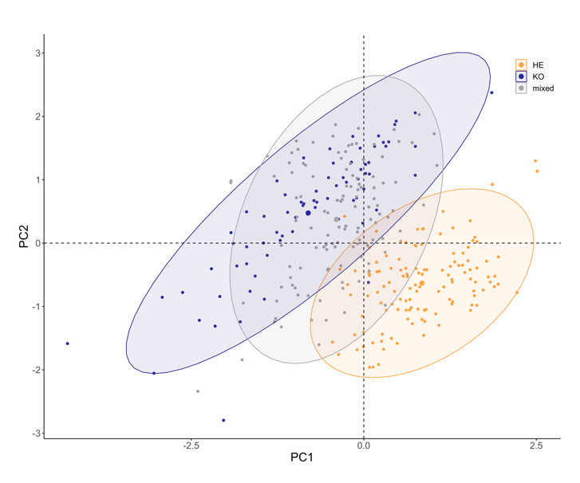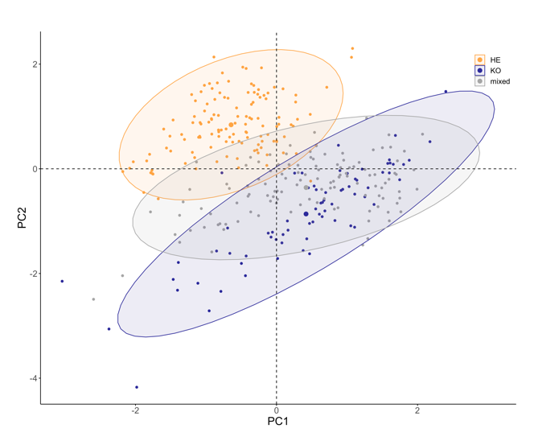

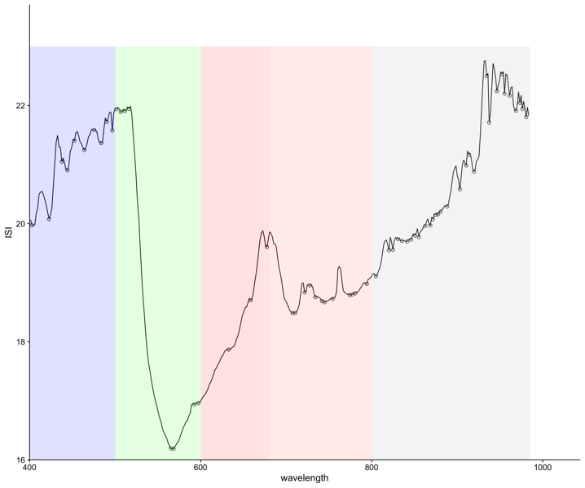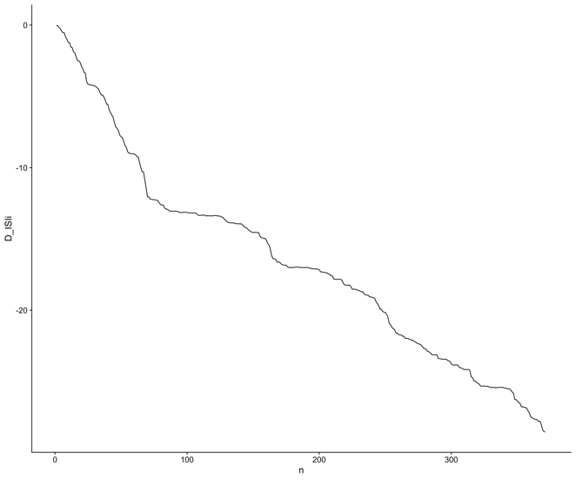

Write about 3 point vs 5 point minima, and the inclusion of highly variable parts of the spectrum



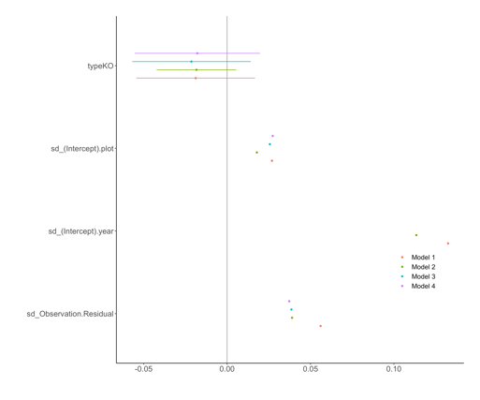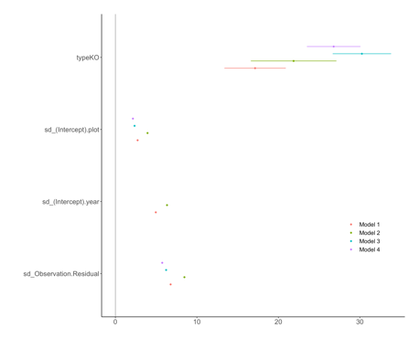

**How does spectral diversity relate to species richness, evenness, and soil-background?**









**Are closer measurements more similar than more distant measurements?**

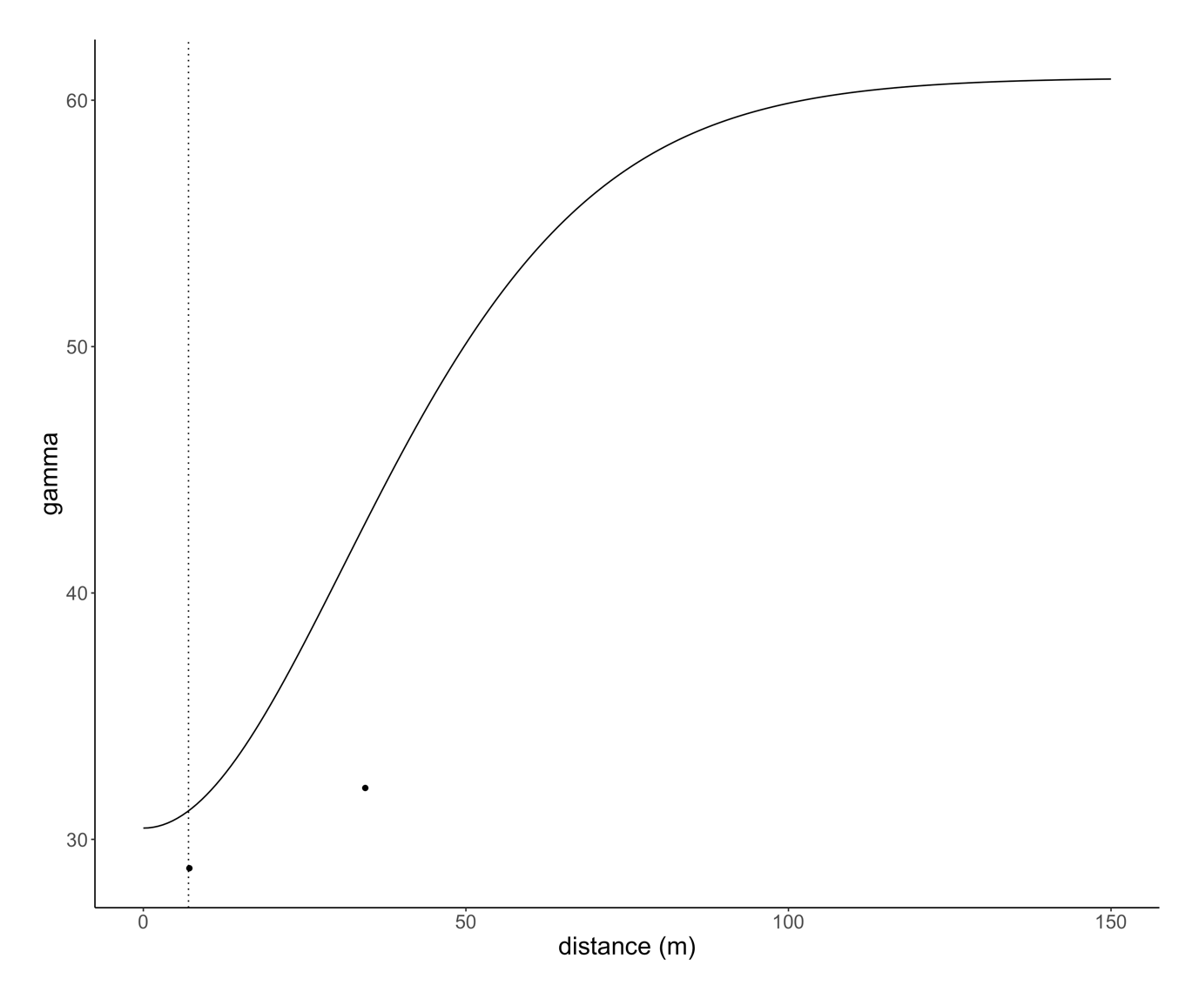

Nugget-to-sill ratio indicates  
the degree of spatial dependence in the data. <0.25 = strong spatial dependence  
0.25-0.75 = a moderate spatial dependence